The current paradigms of thought have led to crises that are self-generated, hybridized without resolving the old ones when new ones emerge. the model for generating new crises from the old ones is presented schematically below

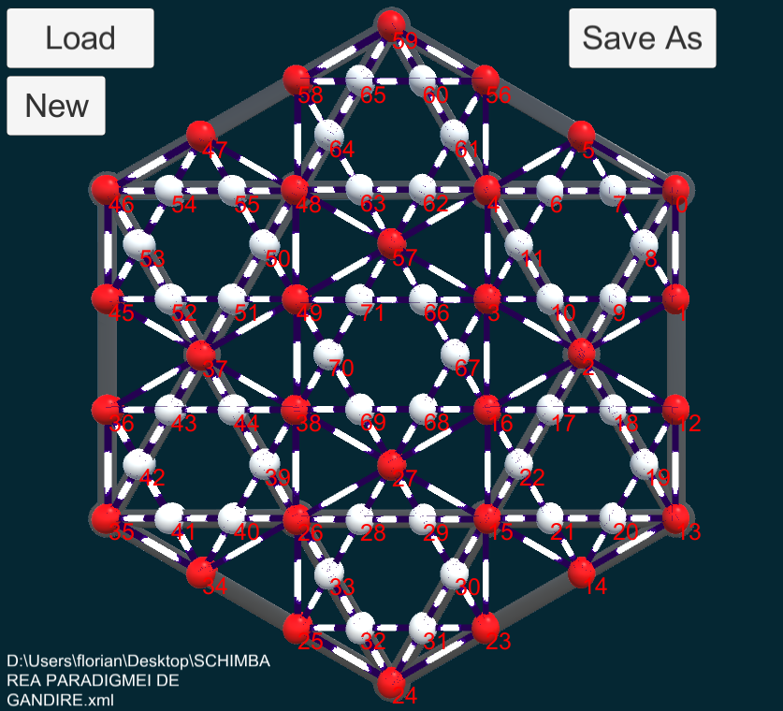

If initially the generating crises were
59 EDUCATION CRISIS
13 CRISIS OF SOCIAL BEHAVIOR
35 THE CRISIS OF PERSONALITY DEVELOPMENT
What can be found at all times in relation to people, there was another set of crises regarding the development of societies
24 THE NATURAL ENVIRONMENT CRISIS
46 THE CRISIS OF SPIRITUAL INVOLUTION
0 THE CRISIS OF MANIPULATION FOR POWER

These generated the behavioral typologies that generated the relational stages with the natural environment
Man was afraid of the environment
Man makes tools to fight the environment
Man begins to destroy the environment
Man controls and degrades the environment
Man struggles to recover the environment
All of these were due to a paradigm of linear and quantitative thinking that did not take into account qualitative or correlative aspects.
Another conclusion is that from 6 initial crises that undermined sustainability, they generated 24 new crises because of the thinking model.

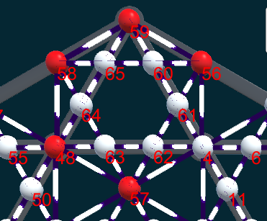the crises that led to the delegation of responsibility, thinking and decision to the elected ones without consulting the people "representative democracy"
57 THE CRISIS OF THE ADAPTATION AND THE BLOCK OF THE EVOLUTION
48 THE CRISIS OF AUTOMATION AND THE LOSS OF CRITICAL ANALYTICAL GOVERNANCE
58 CRISIS OF LOSING THE DEVELOPMENT PERSPECTIVES
59 EDUCATION CRISIS
56 THE CRISIS OF THE LACK OF DISCERNMENT

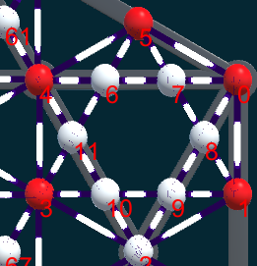crises of control by force and money on human life
3 THE CRISIS OF FOCUS EGOCENTRISM
4 CRISIS OF LINEAR AND DICHOTOMY SETTING
5 CRISIS OF DESTRUCTION OF TRUST IN THE INSTITUTIONS OF THE STATE
0 THE CRISIS OF HANDLING FOR POWER
1 THE CRISIS OF GREED FOR RESOURCES AND OF PLUNDER

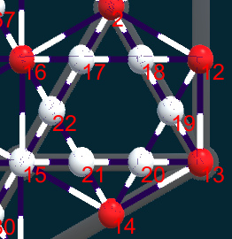the crises of abuse and violence towards the environment and people
16 THE CRISIS OF ENABLING ARMS OF TOTAL DESTRUCTION OF THE PLANET
2 THE CRISIS OF COMPETITIVENESS IN THE DAMAGE OF COLLABORATION
12 THE CRISIS OF FREEDOMS IN THE DAMAGE OF RESPONSIBILITIES
13 CRISIS OF SOCIAL BEHAVIOR
14 CRISIS OF POLLUTION AND DESTRUCTION OF SUSTAINABILITY

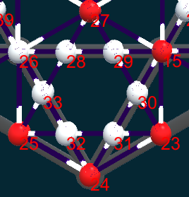the crisis of deadly imbalances for the environment and human populations
27 CRISIS OF GENETIC MUTATIONS IN CASCADE
15 THE CRISIS OF DESTROYING THE ENVIRONMENT CONSIDERED THE RESOURCE, NOT THE SOURCE
23 THE CRISIS OF INABILITY TO RECOVER THE BALANCE AND SUSTAINABILITY
24 THE NATURAL ENVIRONMENT CRISIS
25 THE CRISIS OF LOSS OF VITAL SPECIES FOR EXISTENCE AND REPRODUCTION OF LIFE

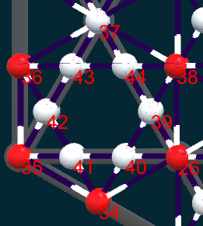the crises of power with the tendency of generalization, without feedback from people or the environment
38 THE CRISIS OF IGNORING ENVIRONMENTAL PROBLEMS WHILE MAKING DECISIONS ON GAINING POWER OR PROFIT
26 THE CRISIS OF SOCIAL INTEGRATION IN THE ENVIRONMENT AND THE SOCIAL ENVIRONMENT
34 THE CRISIS OF ALIENATING PEOPLE FROM THE SPECIES IN THE ENVIRONMENT AND IGNORING THEIR DISAPPEARANCE
35 THE CRISIS OF PERSONALITY DEVELOPMENT
36 THE CRISIS OF EXPANSION OF PEOPLE IN AN ARTIFICIAL ENVIRONMENT, GENERATING HUGE HEALTH PROBLEMS

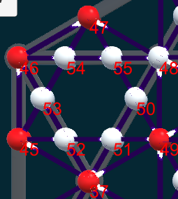the crisis of degradation and degeneration of the elements of humanist civilization
49 THE CRISIS OF MANAGEMENT OF SOCIAL AND ENVIRONMENTAL PHENOMENONS
37 THE CRISIS OF GROWTH OF AGGRESSIVITY AND VIOLENCE
45 THE CRISIS OF DEGRADATION OF CIVILIZATIONS AND THE TRANSITION TO INSTINCTUAL PRIMITIVISM
46 THE CRISIS OF SPIRITUAL INVOLUTION
47 THE CRISIS OF UNREALISTIC LUDICAL THINKING IN STRATEGIC APPROACHES

These sets of crisis that alter the sustainability of human existence on the planet Earth continue with other generated crises that dynamite the global metabolism of the planet, in the sense of GAIA the living planet
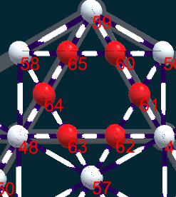the crises of personality degradation
65 crisis of lack of desire for life
60 crisis of lack of direction, purpose and motivation
61 the crisis of unconditional subordination for money
62 the crisis of narrowing skills with specialization in a single operation
63 crisis of total dependence on the institutions
64 crisis of alienation and lack of alternatives

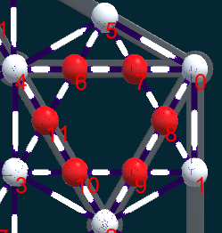the crises of savage imperialism
6 crises of active or passive revolts
7 crisis of population control by force
8 crisis of endemic poverty
9 crisis of speculative strikes and bankruptcies
10 the crisis of the battle for supremacy in any conditions and with any risks
11 the crisis of financial imbalances between the very rich and the rest of the impoverished world

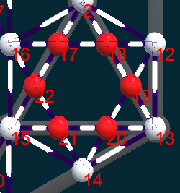the crises of ultimate destruction
17 crisis of mental imbalances at the top of the world decision
18 crises of generalized aggression and fatal wars
19 crises of internal self-destructive wars
20 crises of extreme violence between immigrant and local populations
21 crisis of desertification and environmental destruction
22 the crisis of the illness and the deliberate killing of the population without resources

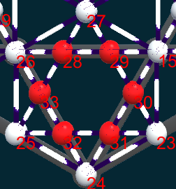crises of the impossibility of recovering systemic balances
28 crisis of health and vitality of human populations or other species
29 crisis of loss of genetic background and collaborative species that maintain the balance of the environment
30 crisis of the destruction of species in cascade
31 crisis of the danger of extinction of life on earth
32 the crisis of the emergence of new species resistant and aggressive to the old ones, adapted to the harsh conditions

33 the crisis of insufficient knowledge for the experimental restoration of the conditions and species affected and in the process of disappearing
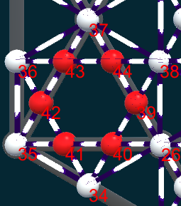
43 crises of weakening the chances of life
44 the crisis of extreme cynicism in decision making and the disappearance of humanism
39 the crisis of the disease of the species in the environment and of the weakening of the capacities to recover its health
40 replacing natural species with artificial technologies equipped with artificial intelligence
41 crises of psychological degeneration of new generations affected by technological changes caused by the environment
42 crises of degeneration of the personality and of stopping or blocking the positive human evolution

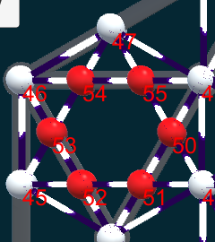managing machine problems with artificial intelligence
54 crisis of incapacity to find crisis management and resolution solutions
55 the excessive development of artificial intelligence concomitantly with the renunciation of the development of human thought
50 automation of daily life and limitation of personal actions that will be controlled by artificial intelligence systems
51 development of teams and technologies capable of managing problems in real time to avoid worsening situations with potential explosive
52 development of populations without education or control, learned to survive in difficult conditions, without rules and ethics
53 the loss of human qualities, which will be replaced by exchange values

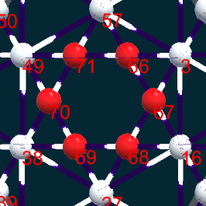
71 selecting the optimal genetic individuals to perform certain operations or functionalities
66 development of artificial life and immortality of the elect
67 development of space escape and tera-forming technologies on other planets
68 formation of clones and cloned tissues to replace degraded components and indefinitely prolong the life of those who have means
69 formation of enclaves and reserves where there will be sustainability, in places isolated by the polluting technological influences
70 depletion of the planet's resources simultaneously with the degeneration of the sustainability of the natural environment
All of these negative scenarios can be avoided by developing another thinking paradigm

